Fernando Zaldivar

February 12, 2019

Lab#1

CS 2302

Data Structures

Spring 2019

**Introduction**

Recursion is a technique used by many computer scientists in order to create different types of software. In this lab we take a look at just some things we can do with recursion, the main one being able to draw different shapes. These shapes can be then arranged in many ways to create figures. In this lab we were given the “skeleton” of two methods, draw_squares and draw_circles. Using these two methods we need to manipulate them in order to create the figures shown below.

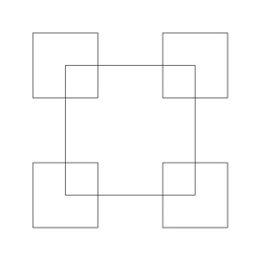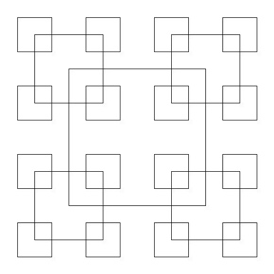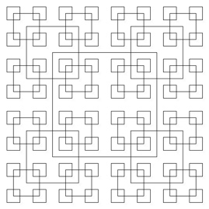

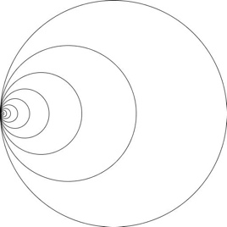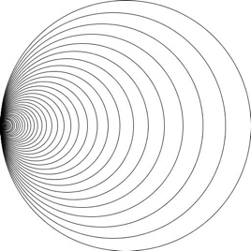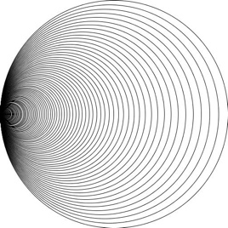

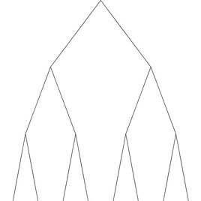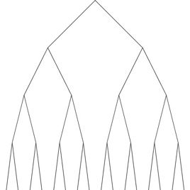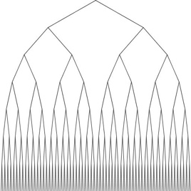

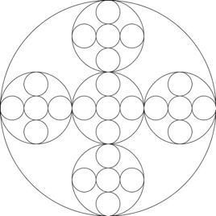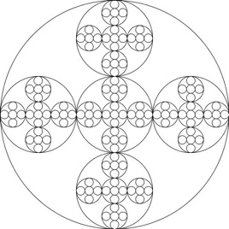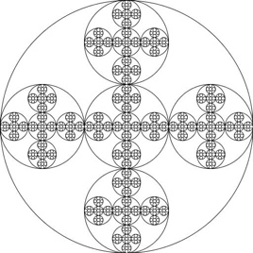

**Solution**

**Squares**

To start off the square figure, the draw_squares method had to be analyzed and broken down. The original method had all the four points of a square inputted and it was manipulated in a way that the square would shrink and rotate. We had to change the method so all it was given was a center and a radius. With the radius it would compute the four corners of the square, then it would add “p” which was the center, therefore the square would be around given center. Then we had to call the method recursively once for every corner and each time divide the radius by 2, this would make a smaller square in each corner of the shape.

**Circles**

In order to accomplish the figure, we see in the figures above we manipulated the draw_circles method. The circle method that was in the same file would stay un-modified. The draw_circles would now call for a center, the number of recursions, the factor by which the circle is decreasing, and the radius of the circle. Each time the method was called the center would get moved by multiplying the x coordinate by .5, the y coordinate would not change. In each recursive call we will pass on the new center, the new radius multiplied by the factor that is being decreased by and the factor.

**Tree**

In This lab the method uses is called draw_figure, and it didn’t come from any of the skeletons given. This method will need the height of the tree, or the number of recursions, the center, the change in x coordinates and the change in y coordinates. The method computes the three plots each branch will need starting from the center, which is given. Then the plot to the left is computed by subtracting half of the x coordinate from the x coordinate, same procedure is repeated with the y coordinates. Then, the right coordinate is computed by adding the change x to the x coordinate and the change in y to the y coordinate, respectively. All of these plots are then stored in array where it can the be drawn. Lastly, we call the method recursively once with the right point and again with the left and subtracting 1 from the height. The change in x and y would not change.

**Circle Pattern**

For this figure we manipulated the draw_circles in a way like we did to draw the square figure. This method called draw_circles_within, would need a number of recursions, a center and a radius. Using the circle method, the first circle was drawn. Then, five more centers were calculated, for the top and bottom circles the x coordinate stayed untouched, but for the top we subtracted the y coordinate plus one third of the radius from the y coordinate, and for the bottom we subtracted one third of the radius minus the y coordinate from the negative radius. For the left and right center, we left the y coordinates untouched, but for the left we added the radius minus one third of the radius to the x coordinate. For the left we subtracted the radius minus one third of the radius from the x coordinate

**Experimental results**

**Squares**

For the squares figures we gave the method a center of (0,0) a radius of 1000 and called it four times. The figure below was produced. As you can see these results were as expexted and identical to the figures we intended to get.

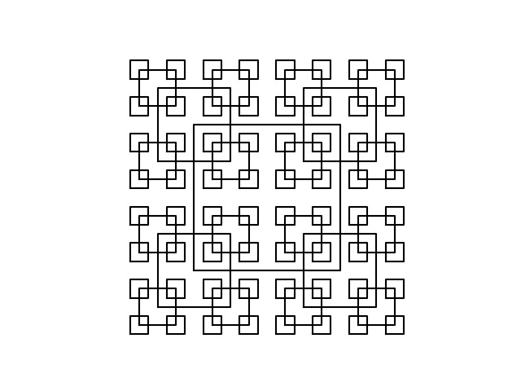

**Circles**

To draw the circle, figure the method was given 5 recursive times the center of 100,0, the radius 100 and the decreasing factor of .5. The figure below was produced. This figure is very similar to the figures we wanted to get, however a down fall is we don’t get as nice figures when we have much more recursion calls.

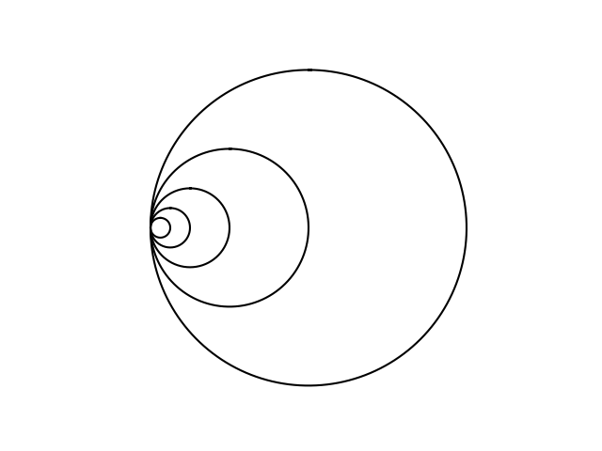

**Tree**

To draw the tree looking figure we gave it a height of 5, the center of (10,10) and the change in x and y 5,5. The figure below was produced.The tree while it did have some characteristics correct did not display something like the figure in the problem. Part of the reason could be that all the coordinates change constantly, and they are all identical.

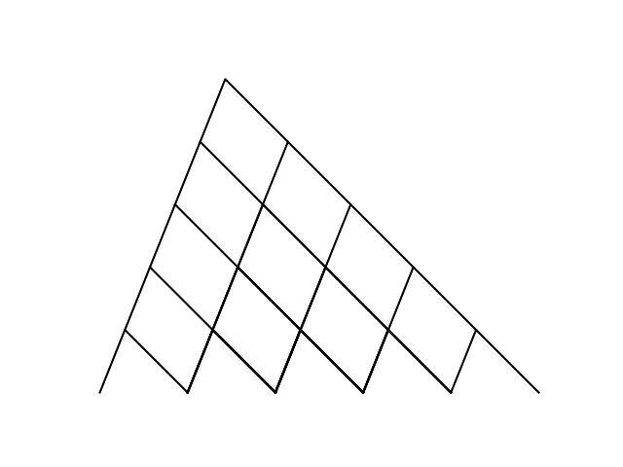

**Circle Pattern**

Like the circle method we used the parameter of the center 100,0 radius of 100 and called it 4 times. The figure below was given. The circle patter was a success and we can see this figure was one the ones given in the problem.

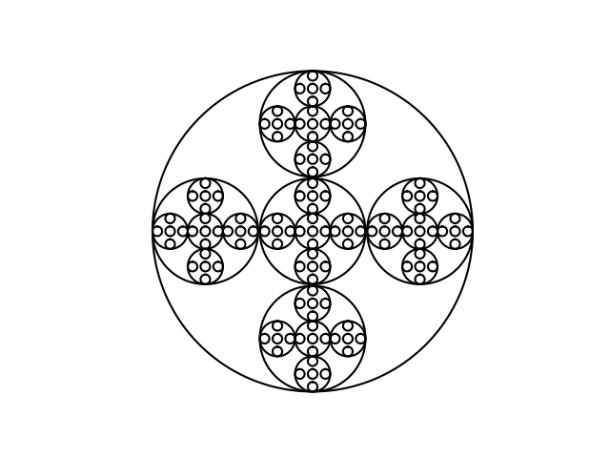

**Conclusion**

A big thing in this lab was learning how to use the numpy and the matploy libraries. We had to draw many figures, so we had to get a lot of practice using coordinates and manipulating them to get the shape you want. We also got to see the behavior of recursion and how the placement of the recursive call effects the way a shape looks but can also affect the way the method is executed.